**CHAPTER 6**

**TESTING**

**6.1 Testing**

In this chapter, I will discuss the Design and implementation of the UPC-A barcode reader in matlab. ``software'' used to decipher the barcode.

In this level we performed ultimate review of software specification, design and code generation, Tried allot in destructive manner to find the errors, bugs, incompletion in the software design and code.

It was performed on each level several times on each level, to find the right best path, Some of the errors are yet un-covered as yet-undiscovered. many test cases designed to uncover errors/ bugs and fix them.

**6.2 Software**

The software for this system is organized as a number of functions that are defined within the modules they relate to, with some of them kept at the top level. but in order for it to be useful, there needs to be some logical organization for a test.

We decided to organize all tests in small groups. These groups were to be the smallest independent testing units in the system. In other words, the smallest piece of code that can accomplish a useful test is a ``test group.'' This ``test group'' called a ``test sequence''

### 

**6.3 White Box Testing**

To examine in deep that each and every condition is right and working properly, white box testing is performed,

All the numeric execution is working fine as directed. By checking out the intensity results. and loops.

All independent paths, logical-decisions, loops and internal data structure are exercised.

All independent paths "Cyclomatic Complexity" for testing are performed. Basic paths are also tested.

### 6.3.1 Execute Phase

In this phase, all the functions to be execute are carried out. and executed independently, there systematic execution is also mentioned in the Algorithm Section of the thesis.

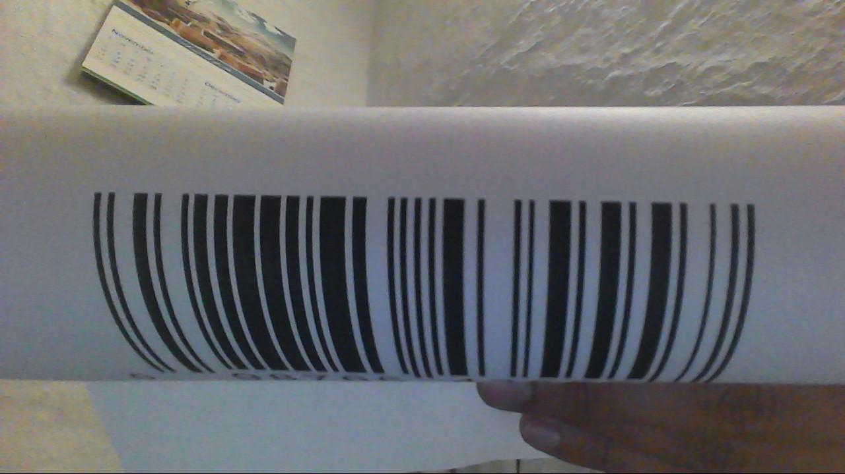 Some of the images are given as input, below



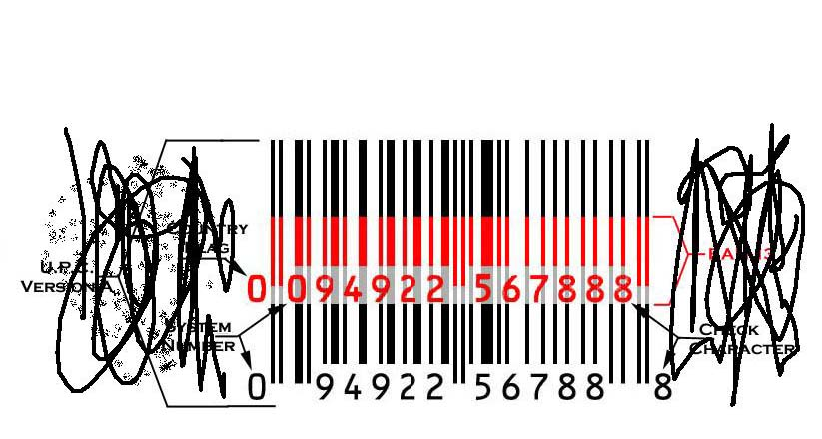

Got the exact result which was encoded in barcode.

**6.3.2 Loop Testing**

loop testing is the major part in testing our software basis on loops, different conditions are applied on these loops.

Got that all of the loops are working well according to there desired path, the inner loops are also congusted to the outer loops and working well, all of nested loops are working fine.

### 6.3.2 Check Phase

In this final phase of the test group, the results are checked , since information that we will got will only be in the numerical string form, a relatively easy task because its already numeric data. This gives a very simple check; read the original barcode and result same for each value.

On all images which are downloaded from internet or clear, software is working approximately 99.9% fine , and the images captured from cam in proper lightning conditions are also giving fine result, up to 80%, as compared to the barcode readers implemented in matlab up till now most of them are not supporting the webcam images but our software successfully decipher them.

**6.4 Black Box Testing**

Examined all fundamental interface aspects without regard to the internal structure, Tried most of the time to make it as much user friendly as much possible, so any one can easily operate it,

### 

**6.5 Conclusion**

Barcode reading algorithm implemented in matlab is working better then the other barcode algorithms implemented in matlab, and gives 90% right result in the proper lightning.